Приложение 1
evaluative table
criteria | Pair 1 | Pair 2 | Pair 3 | Pair 4
1.was the dialogue interesting/unusual
2.did the speakers talk clearly/loudly
3. material was interesting

Приложение 2

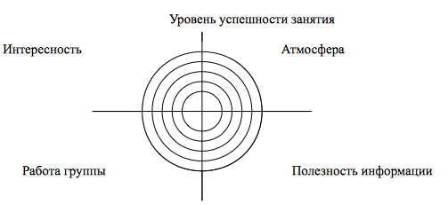
My card of success

atmosphere of a lesson
Intersting

Profit of information
My pair

Приложение 3
